Part D – MATLAB Investigation

D1 – Generate and plot signals

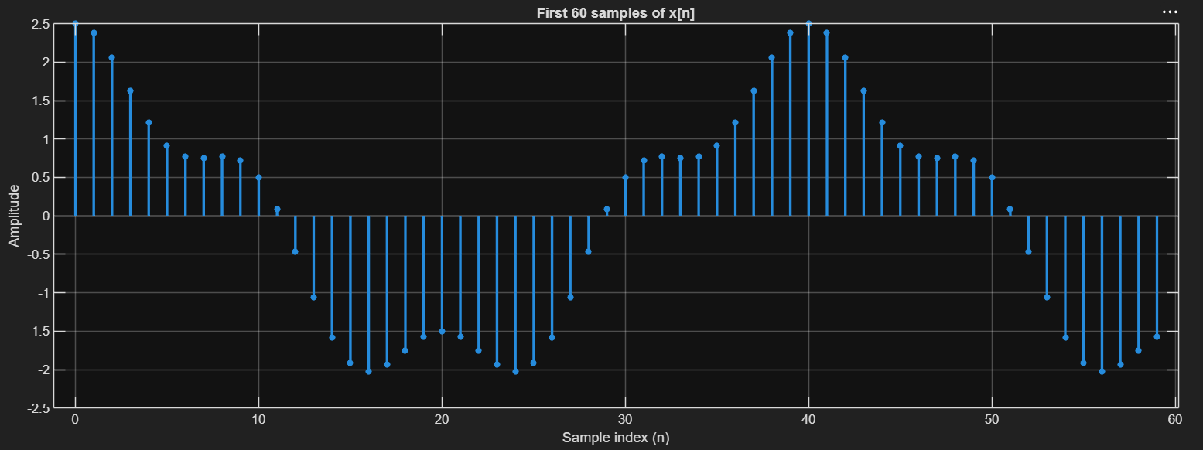

D2 – Simple Predictor

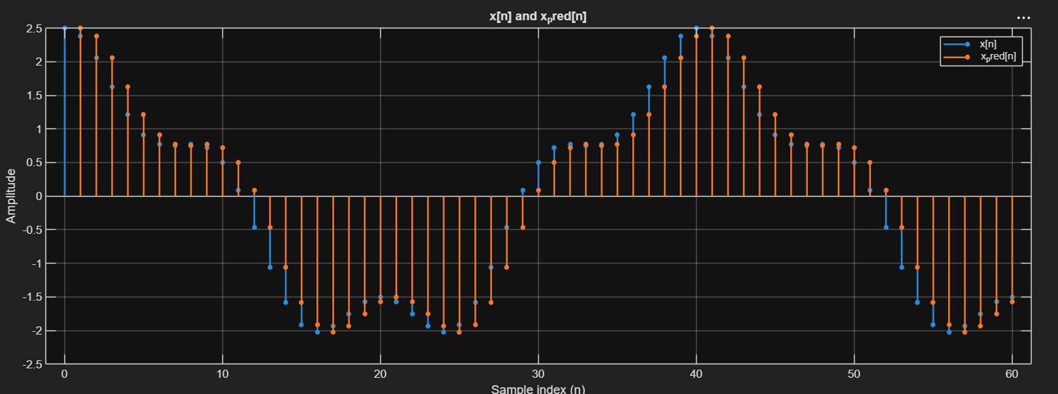
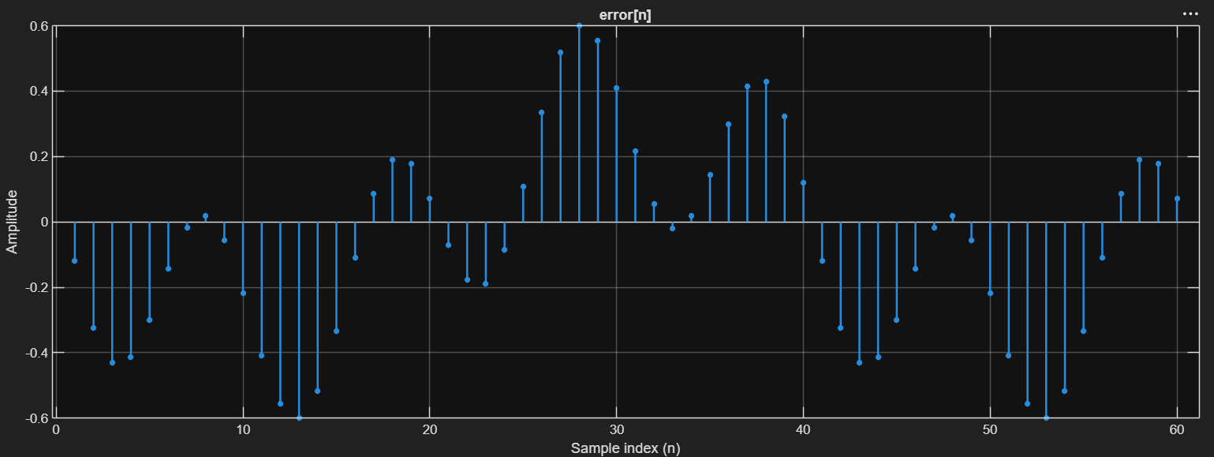

Question: From the figures, explain why e[n] is generally smaller than x[n].
Answer: because the signal has significant correlation between adjacent samples, x and x_pred are close to each other, which reduces the difference between them, thus reducing the value of e[n].

D3 – Prediction Gain
After calculating Px, Pe, Gp, Gp(db) by MATLAB code we got these values:
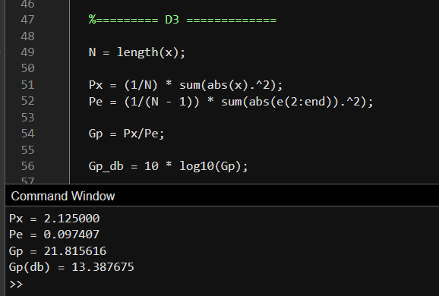
Question: Calculate the prediction gain. What does a large prediction gain mean?
Answer:
Prediction Gain turned out to be 21.81 = (13.39 db).
Prediction Gain means basically gives an idea of how much smaller the power of e[n] is compared to x[n], so a large Gp means that prediction error has significantly lower power than the original signal, indicating that the predictor is working well.

